Cairo University

Faculty of Computers and Information

CS251 Software Engineering I

Course Project

2013

**Sprint Planning Report**

Reversi Game

Challengers

|  |  |  |  |  |
| --- | --- | --- | --- | --- |
| **ID** | **Name** | **Email** | **Dept/Grp** | **Mobile** |
| 20120605 | محمد عدنان حمدي البقاعي | adnanalbukaai@gmail.com | CS-5 | 01159750246 |
|  | انس نصوح سبيناتي | bloggersb92@gmail.com | CS-5 | 01147793670 |
| 20110486 | حازم محمود الشناوى | hazemelshenawy93@yahoo.com | CS-5 | 01142509737 |
| 20070413 | عمرو السيد أحمد | amr.ahmed1431@gmail.com | CS-5 | 01115836690 |
| 20080267 | محمد محمود ابراهيم | mohammad.mahmoud91@gmail.com | CS-5 | 01110902064 |

1. We done only 95% of work so far, because we have a lot of assignments.
2. The Burndown Chart
3. Screenshot for Trello and for Bitbucket

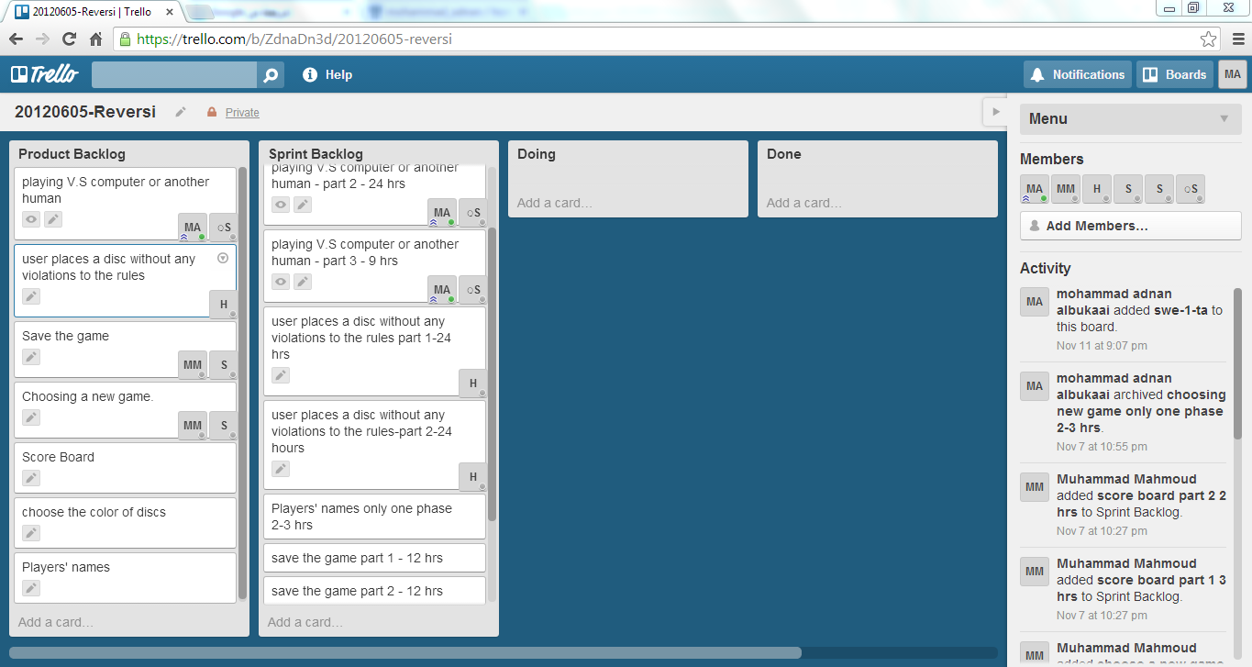

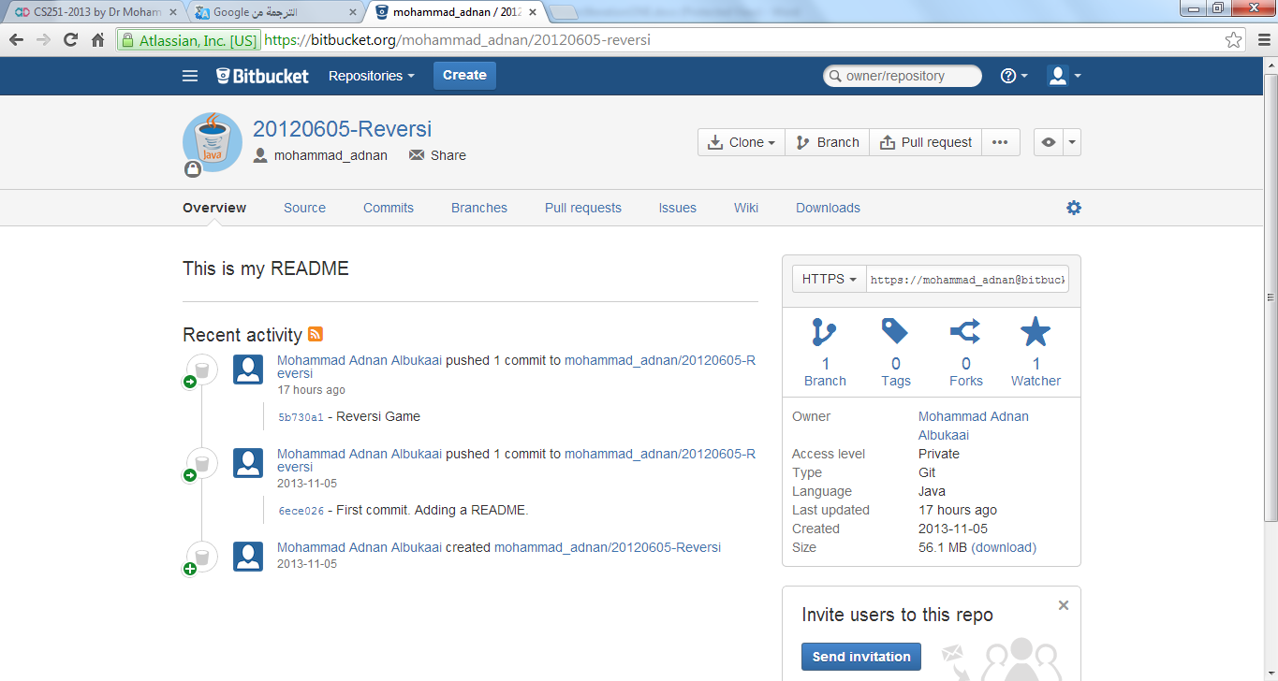

1. The design (class diagram)

